**Harris Corner Detector implementation in Python**

Code is divided in functions. Matplotlib is used to draw graphs and scikit library is used to convert image to grayscale because cv2 grayscale function did not give satisfactory results. Corner function takes the grayscale input image and calculates its corners. Horizontal and vertical shifts were earlier done by calculating shift matrix and then by warpaffine function, the matrix was applied to grayscale image. Since the resulting image was not satisfactory, sobel filters were then used to implement shifts. After calculating corners, thresholding was carried out to reduce the number of corners in the image. Alpha for calculating trace square is 0.04. Thresholding is at 120px (means all the pixel values below this value will become zero and all above this value will be set to 255).

Rotation function contains the part b of the assignment while scaling function contains the part c of the assignment. In both part b and c, same logic is used to compare the number of points between images. Inner loop translate window across width of the image and outside loop translate window across height of the image. First for loop in rotation function is to rotate image. Since 360/15=24, hence it runs for 24 times. Similarly, first loop in scaling function runs for 8 times.

cnr_scld = cv2.resize(cnr_orig, None, None, factor, factor, cv2.INTER_CUBIC)

cv2.INTER_CUBIC in resize line of scaling is for implementing bicubic interpolation. Match variable is the number of features which is set to zero before window loops start.

Key_points_n function at the end of the code is to calculate number of features (N) is the original image. It uses the same algorithm as the one used in part b and c except the fact that in this function both images compared are the same hence giving the total number of features in either image.

Program run time for image1: 72.0956998

Program run time for image2: 72.6335488

**Main function output:**

Height: 480, Widht: 640

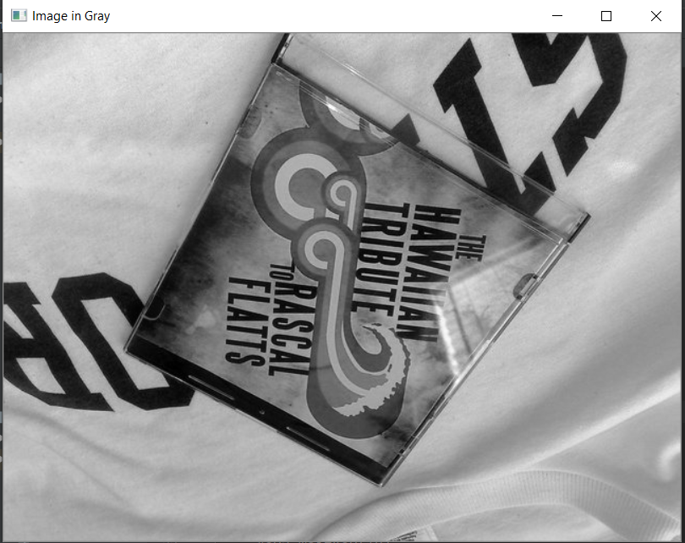

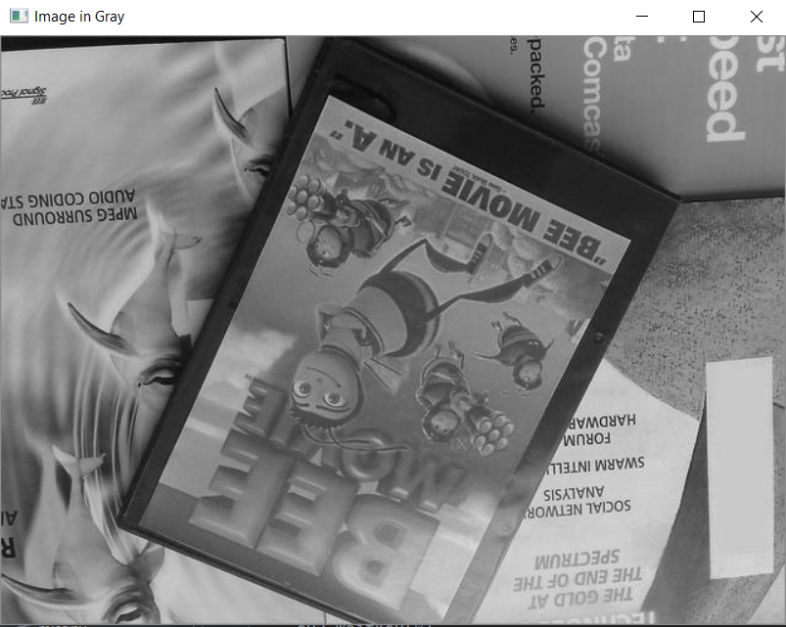

**Corner function output:**

**For image1:**

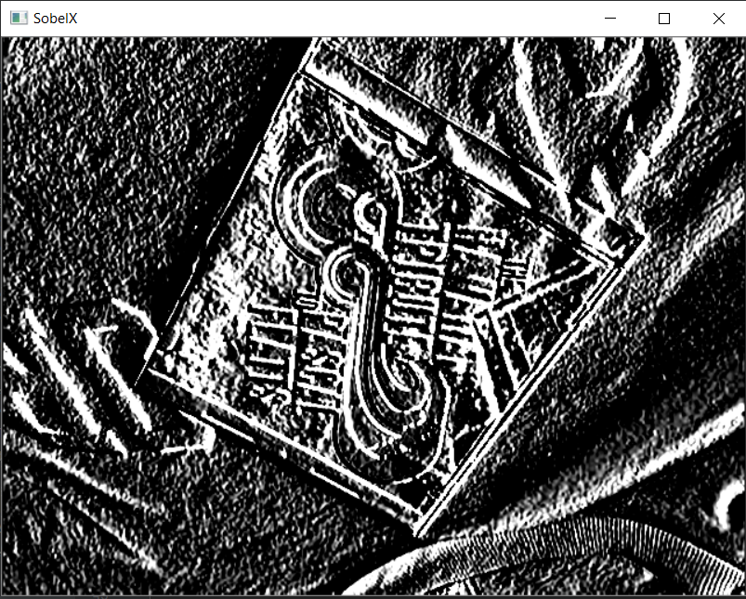

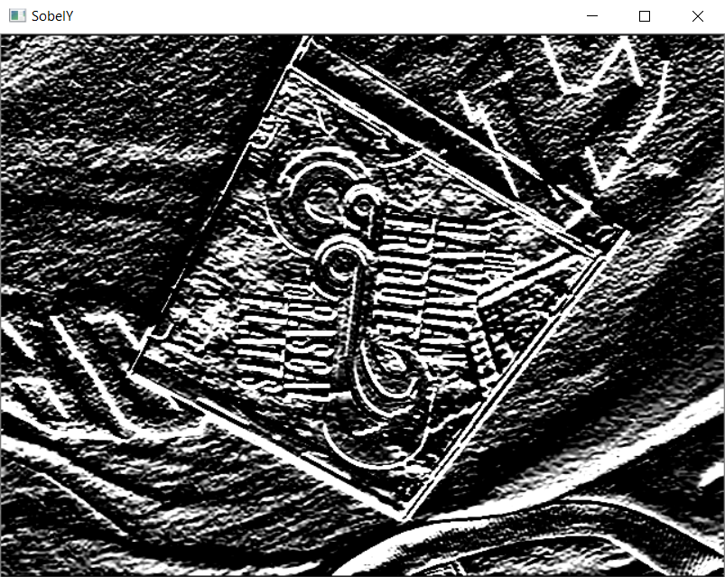

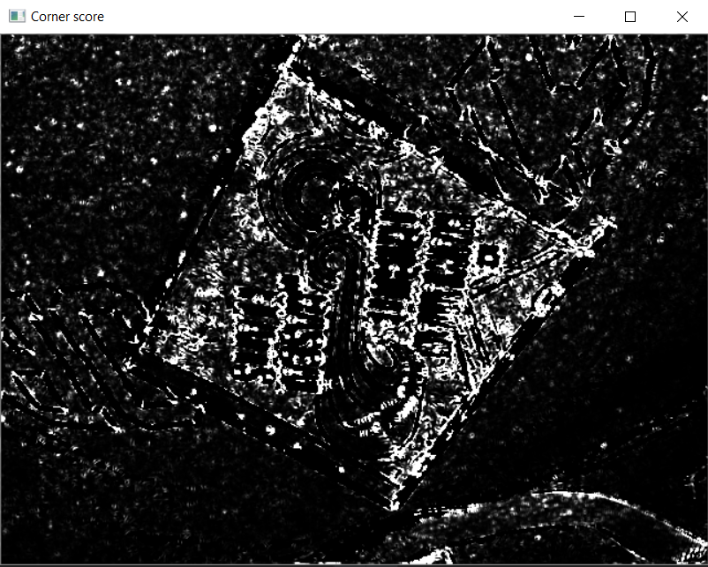

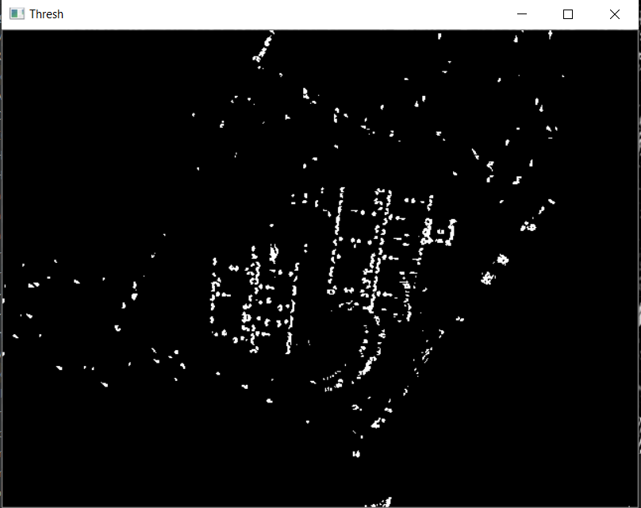

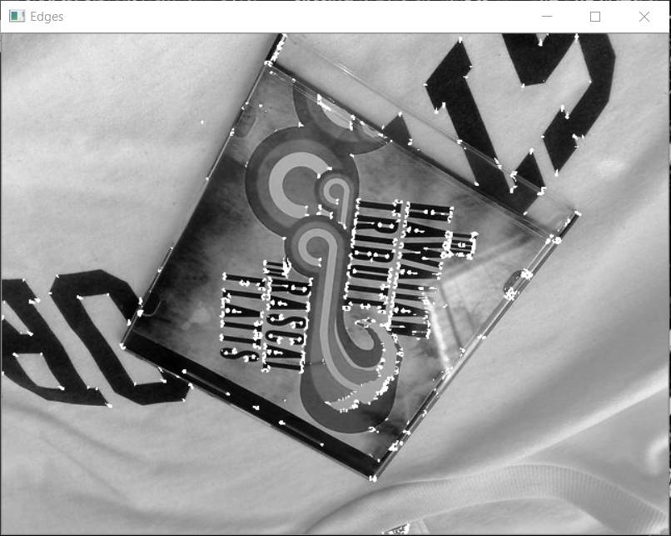

**For image2:**

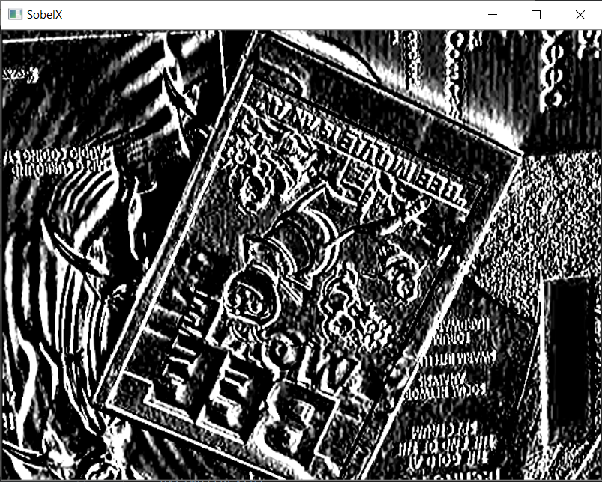

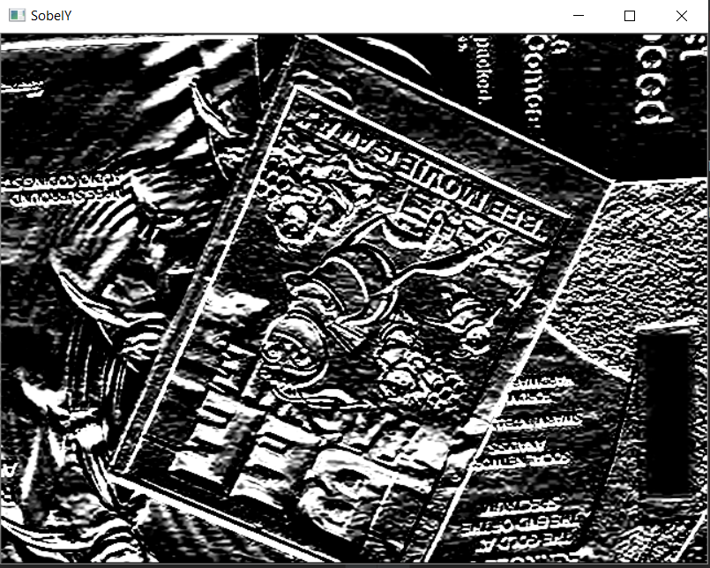

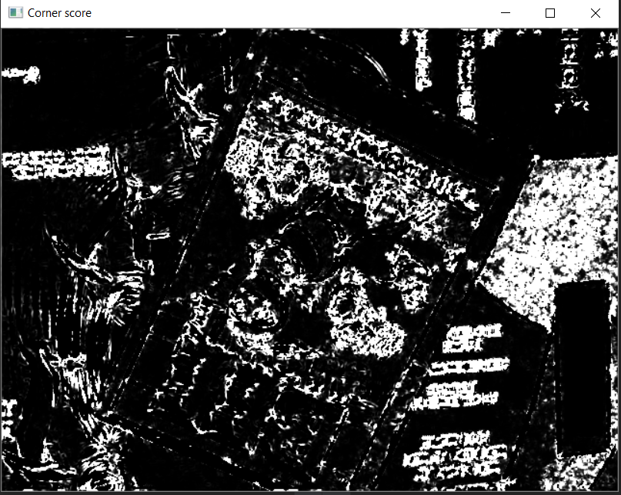

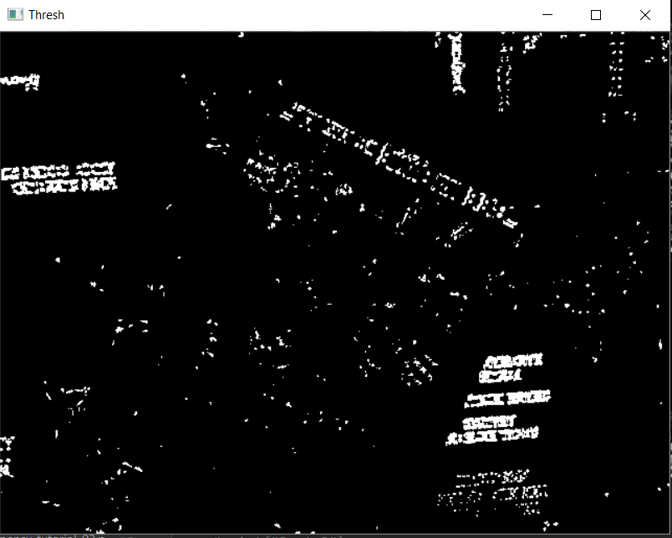

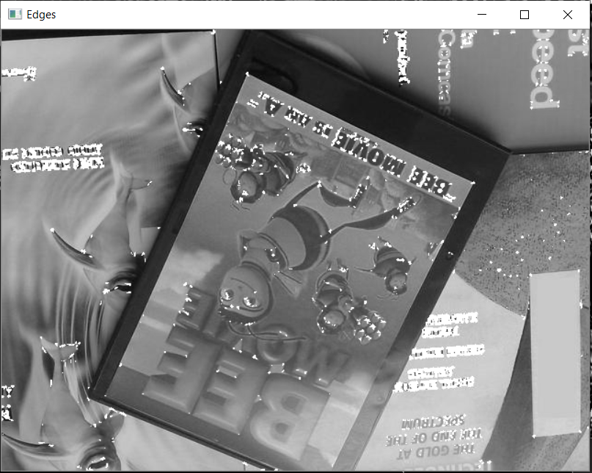

**Rotation function output:**

**For image1:**

At 15-degree rotation: Matches: 4872

At 30-degree rotation: Matches: 4850

At 45-degree rotation: Matches: 4771

At 60-degree rotation: Matches: 4740

At 75-degree rotation: Matches: 4702

At 90-degree rotation: Matches: 5144

At 105-degree rotation: Matches: 4834

At 120-degree rotation: Matches: 4902

At 135-degree rotation: Matches: 4959

At 150-degree rotation: Matches: 4974

At 165-degree rotation: Matches: 4910

At 180-degree rotation: Matches: 5252

At 195degree rotation: Matches: 4871

At 210-degree rotation: Matches: 4837

At 225-degree rotation: Matches: 4789

At 240-degree rotation: Matches: 4731

At 255-degree rotation: Matches: 4711

At 270-degree rotation: Matches: 5142

At 285-degree rotation: Matches: 4832

At 300-degree rotation: Matches: 4905

At 315-degree rotation: Matches: 4957

At 330-degree rotation: Matches: 4951

At 345-degree rotation: Matches: 4920

At 360-degree rotation: Matches: 5253

(M/N)-> Repeatability: [0.9274700171330669, 0.9232819341328764, 0.908242908814011, 0.9023415191319246, 0.8951075575861412, 0.9792499524081477, 0.9202360555872835, 0.9331810394060537, 0.9440319817247287, 0.9468874928612222, 0.9347039786788501, 0.9998096325909004, 0.9272796497239673, 0.9208071578145821, 0.9116695221778032, 0.9006282124500286, 0.8968208642680373, 0.9788692175899486, 0.9198553207690844, 0.9337521416333524, 0.9436512469065296, 0.9425090424519322, 0.9366076527698458, 1.0]

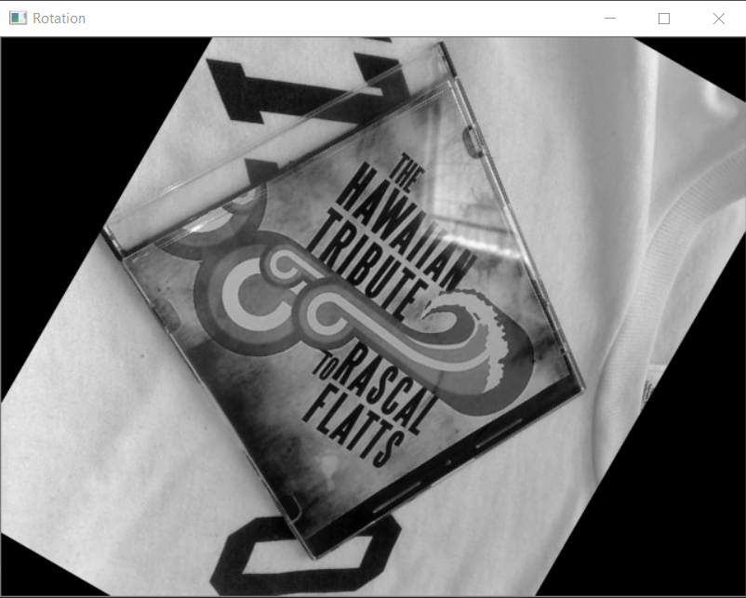

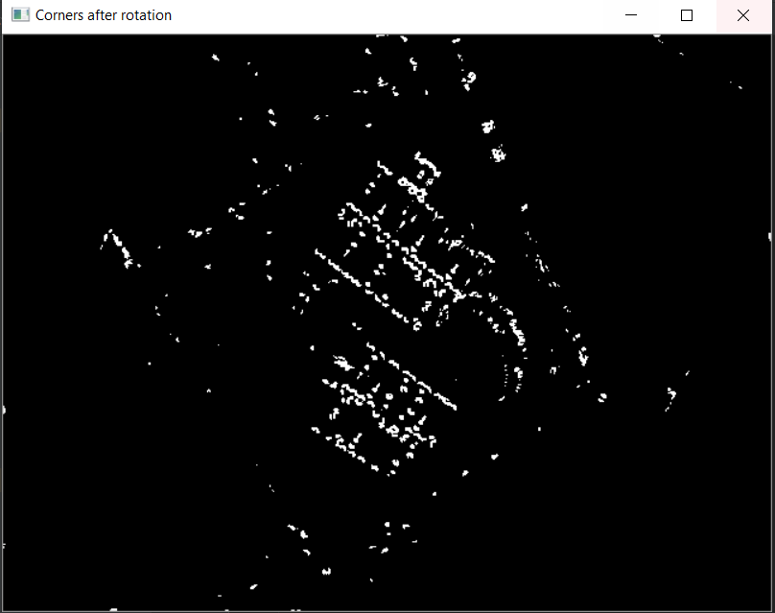

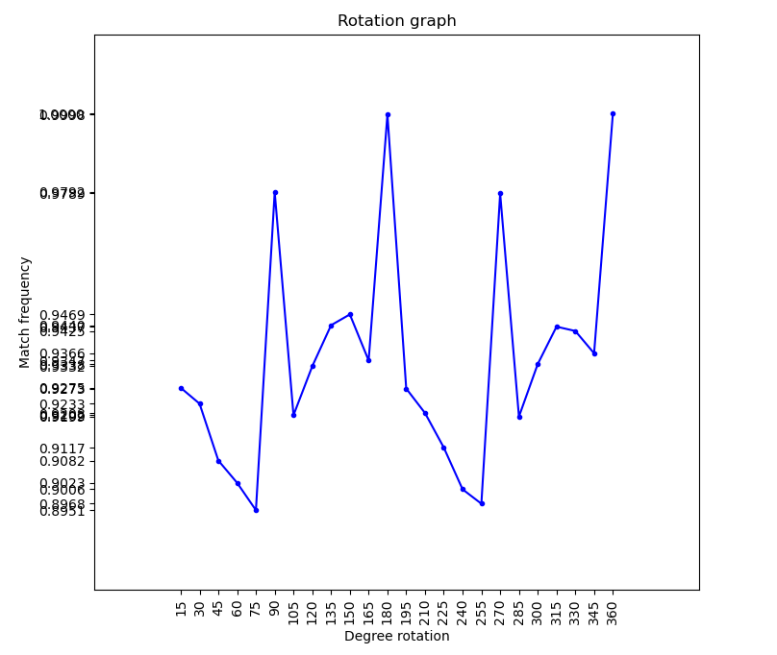

**For image2:**

At 15-degree rotation: Matches: 7023

At 30-degree rotation: Matches: 6834

At 45-degree rotation: Matches: 6935

At 60-degree rotation: Matches: 7221

At 75-degree rotation: Matches: 6734

At 90-degree rotation: Matches: 7403

At 105-degree rotation: Matches: 6247

At 120-degree rotation: Matches: 6133

At 135-degree rotation: Matches: 6181

At 150-degree rotation: Matches: 7050

At 165-degree rotation: Matches: 7567

At 180-degree rotation: Matches: 9318

At 195-degree rotation: Matches: 6992

At 210-degree rotation: Matches: 6788

At 225-degree rotation: Matches: 6912

At 240-degree rotation: Matches: 7164

At 255-degree rotation: Matches: 6784

At 270-degree rotation: Matches: 7448

At 285-degree rotation: Matches: 6281

At 300-degree rotation: Matches: 6168

At 315-degree rotation: Matches: 6205

At 330-degree rotation: Matches: 7063

At 345-degree rotation: Matches: 7538

At 360-degree rotation: Matches: 9428

(M/N)-> Repeatability: [0.7449087823504454, 0.7248621128553245, 0.7355748833262622, 0.7659100551548579, 0.7142554094187527, 0.7852142554094188, 0.6626007636826474, 0.6505091217649555, 0.65560033941451, 0.7477725922783199, 0.8026092490453967, 0.9883326262197709, 0.7416207042851082, 0.7199830292745015, 0.7331353415358507, 0.7598642341960119, 0.7195587611370386, 0.7899872719558761, 0.6662070428510819, 0.6542214679677556, 0.6581459482392872, 0.7491514637250742, 0.7995333050487908, 1.0]

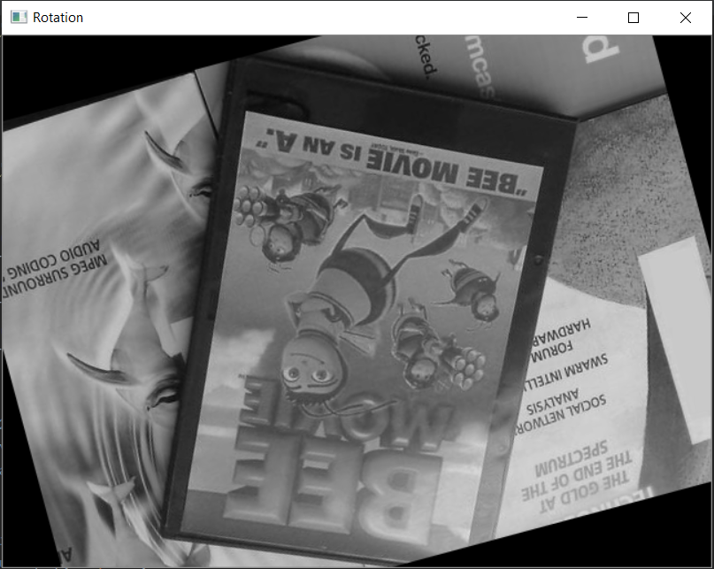

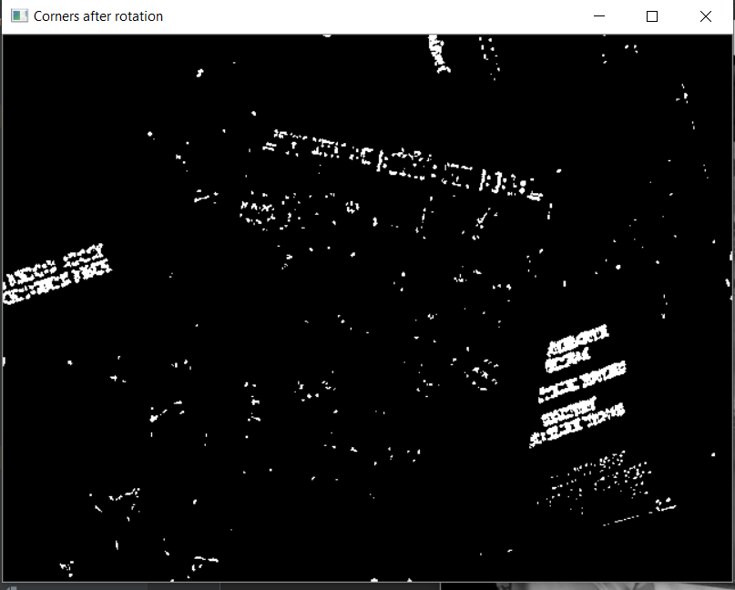

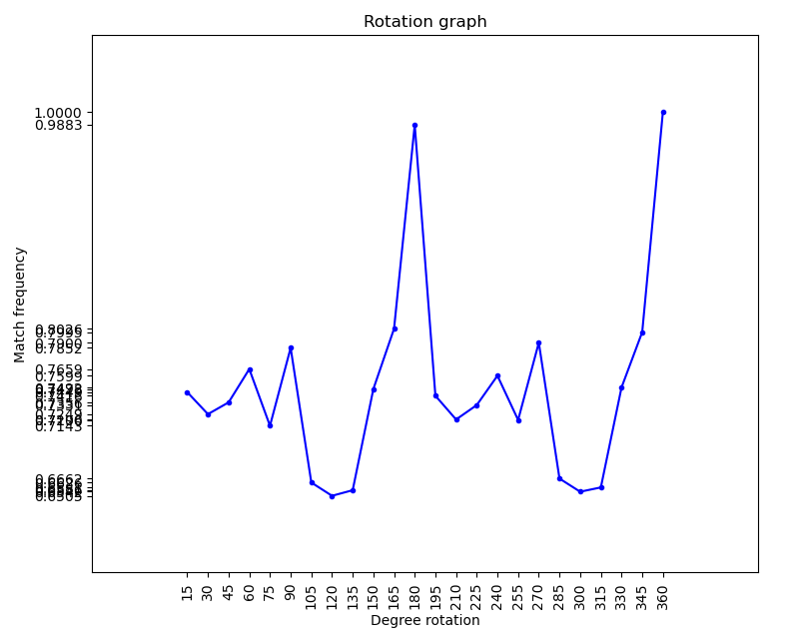

**Scaling function output:**

**For image1:**

Scaling factor: 1.0, Matches: 5253

Scaling factor: 1.2, Matches: 5481

Scaling factor: 1.44, Matches: 4581

Scaling factor: 1.7279999999999998, Matches: 2432

Scaling factor: 2.0736, Matches: 812

Scaling factor: 2.4883199999999994, Matches: 187

Scaling factor: 2.9859839999999993, Matches: 13

Scaling factor: 3.583180799999999, Matches: 0

(M/N)-> Repeatability: [1.0, 1.0434037692747002, 0.8720731010850943, 0.46297353893013515, 0.15457833618884448, 0.03559870550161812, 0.002474776318294308, 0.0]

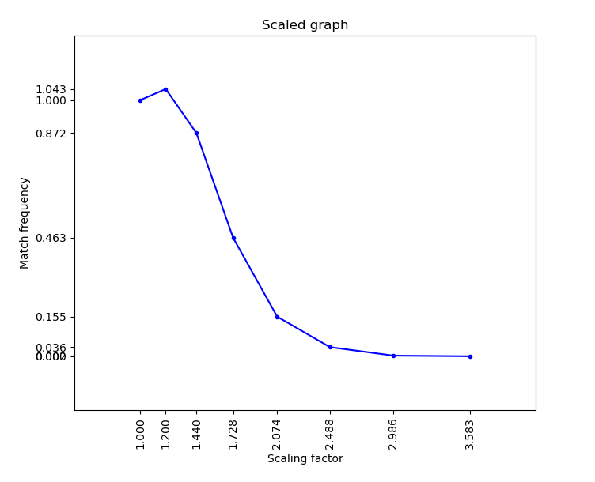

**For image2:**

Scaling factor: 1.0, Matches: 9428

Scaling factor: 1.2, Matches: 9552

Scaling factor: 1.44, Matches: 5847

Scaling factor: 1.7279999999999998, Matches: 4195

Scaling factor: 2.0736, Matches: 3991

Scaling factor: 2.4883199999999994, Matches: 4006

Scaling factor: 2.9859839999999993, Matches: 4233

Scaling factor: 3.583180799999999, Matches: 2078

(M/N)-> Repeatability: [1.0, 1.0131523122613493, 0.6201739499363598, 0.4449512091641918, 0.4233135341535851, 0.4249045396690709, 0.4489817564700891, 0.22040729741196435]

